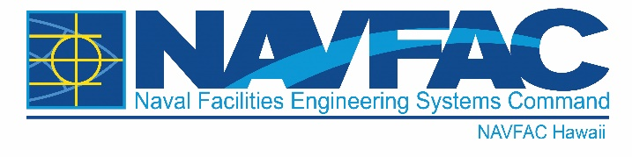

NEWS RELEASE -
NAVFAC HAWAII PUBLIC AFFAIRS OFFICE

FOR IMMEDIATE RELEASE: March 12, 2023 Release No. 23-01

Contact: Corwin Colbert, Public Affairs Officer Commanding Officer
Email: corwin.m.colbert.civ@us.navy.mil Naval Facilities Engineering Systems
Author: NAVFAC Headquarters Command, Hawaii
Ofc: 808-471-7300 400 Marshall Road
Cel: 808-457-7497 JBPHH HI 96860-3139
Fax: 808-474-5479
NAVFAC Hawaii Awards $8.5 Million contract Wastewater Reclamation Facility

JOINT BASE PEARL HARBOR-HICKAM, Hawaii – Naval Facilities Engineering Systems Command (NAVFAC) Hawaii awarded an $8,530,000 firm-fixed-price task under a previously-awarded contract to Hensel Phelps Construction Co. March 7.
This project proposes to repair the secondary clarifiers at the Water Reclamation Facility secondary clarifier at Marine Corps Base Hawaii. Work is expected to be completed by March 2024.
Work includes removing the rotating sludge collection rake mechanism within the existing secondary clarifier and installing a replacement rake mechanism, including scum skimmer, replacement sludge valves, isolation valves on inlet and outlet pipes, lead paint remediation, floor grout replacement, tank coating, temporary modification of the chlorine contact tanks with sludge and scum removal, temporary effluent filter systems, and incidental related work.
“Marine Corps Base Hawaii looks forward to completion of this critical planned maintenance and repair project to our Wastewater Reclamation Facility,” said Cmdr. Ryan Thurn, Director, Facilities Department, Marine Corps Base Hawaii. “This project will improve the functionality and treatment of waste products from the Wastewater Reclamation Facility, and is one of many efforts to improve and modernize our system. Additional design and construction measures were implemented on the project to minimize risk of any potential exceedances and ensure we continue to protect the health and safety of our surrounding waters and community.”
This contract was competitively procured via Procurement Integrated Enterprise Environmental website, with five offers received and is expected to be completed by Feb. 2024.
For more information about NAVFAC Hawaii and/or Naval Facilities Engineering Systems Command visit:
www.navfac.navy.mil .
Naval Facilities Engineering Systems Command: The Facilities and Expeditionary Combat Systems Command
NAVFAC is the Naval Shore Facilities and Expeditionary Systems Command that plans, builds, and maintains sustainable facilities, delivers environmental, utilities and other base services, and acquires and manages expeditionary combat force systems and equipment. We are a global organization with a workforce of over 22,900, Government civilians, foreign national employees, contractors and military (active and reserve) with an annual volume of business in excess of $15 billion.
For more information about NAVFAC Hawaii, visit us at www.navfac.navy.mil/navfac_worldwide/pacific/fecs/hawaii.html, www.facebook.com/navfachawaii/, www.twitter.com/navfac, and/or www.flickr.com/photos/navfac.
Naval Facilities Engineering Systems Command: www.navfac.navy.mil

